* [>>Meeting 2014](http://www.eurospine-spring.com/travel-and-accommodation/accommodation/)
  + [>>Welcome Message](http://www.eurospine-spring.com/meeting-2014/welcome-messages/)
  + [>>Keydates](http://www.eurospine-spring.com/category/keydates/)
  + [>>Venue](http://www.eurospine-spring.com/meeting-2014/venue/)
  + [>>General Information](http://www.eurospine-spring.com/meeting-2014/general-information/)
  + [>>Registration](http://www.eurospine-spring.com/meeting-2014/registration/)
  + [>>Abstract Submission/Call for Papers](http://www.eurospine-spring.com/meeting-2014/abstract-submissioncall-for-papers/)
* [>>Programme](http://www.eurospine-spring.com/travel-and-accommodation/accommodation/)
  + [>>Scientific Programme](http://www.eurospinemeeting.com/programme_2014)
  + [>>Networking Programme](http://www.eurospine-spring.com/programme/networking-programme/)
* [>>Travel & Accommodation](http://www.eurospine-spring.com/travel-and-accommodation/)
  + [>>About Prague](http://www.eurospine-spring.com/travel-and-accommodation/about-liverpool/)
  + [>>How to get there](http://www.eurospine-spring.com/travel-and-accommodation/how-to-get-there/)
  + [>>Accommodation](http://www.eurospine-spring.com/travel-and-accommodation/accommodation/)
  + [>>Map](http://www.eurospine-spring.com/travel-and-accommodation/map/)
* [>>Exhibitors & Sponsors](http://www.eurospine-spring.com/exhibitors-and-sponsors/)
* [>>Contact](http://www.eurospine-spring.com/contact/)

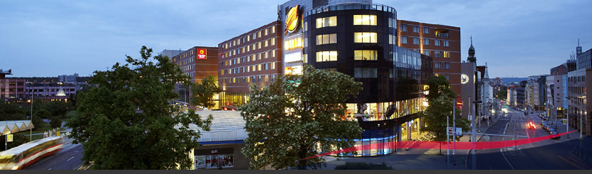

Travel & Accommodation

Accommodation

A special allocation of rooms has been secured at the Clarion Congress Hotel Prague \*\*\*\* and room bookings will be managed directly by the hotel.

The hotel offers a total of 559 Rooms and Suites, which are all non-smoking, a range of different restaurants, bars and parking spaces.

To book your room click on the button below:

[http://www.eurospine-spring.com/wordpress/wp-content/uploads/2012/11/Accomodation_booking.png](http://www.clarioncongresshotelprague.com/en/conference-hotel-prague/EuroSpine-2014/)

**Room prices**

Early bird rates secured on bookings **before 30.12.2013**:  
Standard Single/Double Room                                 105 EUR  
Executive Single/Double Room                                135 EUR

Rate includes buffet breakfast, internet connection, tea & coffee making facilities, all local taxes and 15% VAT.

Special rates secured on bookings **from 31.12.2013**:  
Standard Single/Double Room                                 120 EUR  
Executive Single/Double Room                                150 EUR

Rate includes buffet breakfast, internet connection, tea & coffee making facilities, all local taxes and 15% VAT.

[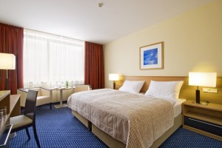](http://www.eurospine-spring.com/wordpress/wp-content/uploads/2012/06/Standard-room-1.jpg)[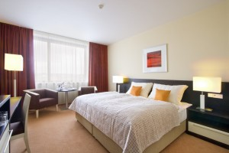](http://www.eurospine-spring.com/wordpress/wp-content/uploads/2012/06/Executive-room-1.jpg)[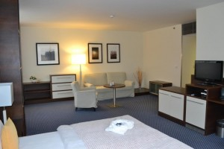](http://www.eurospine-spring.com/wordpress/wp-content/uploads/2012/06/Junior-Suite.jpg)

Standard Room                               Executive Room                            Junior Suite (on request)

**Room facilitie**s

* free Wi-Fi / wired internet connection
* individually adjustable air-conditioning units
* direct dial phone
* LCD SAT and Pay TV
* safe-deposit box
* minibar
* iron & ironing board
* bathroom with bathtub, WC and hair dryer
* executive rooms and suites offer a number of benefits, such as free minibar consumption, tea and coffee making facilities, access to the Club Lounge, which provides soft drinks and small refreshments throughout the day, a PC with internet connection, local and foreign press, etc.

For more information & group accommodation bookings please contact:

**Clarion Congress Hotel** **Prague \*\*\*\***  
Ms. Tereza Staňková  
Freyova 33, CZ – 190 00, Prague 9 – Vysočany  
Phone: +420 211 131 153  
E-mail: stankova@cchp.cz  
cpihotels.cz, cchp.cz

[Programme](http://www.eurospinemeeting.com/programme_2014" \t "_blank)

[[](http://www.eurospinemeeting.com/programme_2014)](http://www.eurospinemeeting.com/programme_2014" \t "_blank)

[Registration](http://www.eurospine-spring.com/meeting-2014/registration/" \t "_self)

[[](http://www.eurospine-spring.com/meeting-2014/registration/)](http://www.eurospine-spring.com/meeting-2014/registration/" \t "_self)

[Travel](http://www.eurospine-spring.com/travel-and-accommodation/" \t "_self)

[[](http://www.eurospine-spring.com/travel-and-accommodation/)](http://www.eurospine-spring.com/travel-and-accommodation/" \t "_self)

[Downloads](http://www.eurospine-spring.com/downloads/" \t "_self)

[[](http://www.eurospine-spring.com/downloads/)](http://www.eurospine-spring.com/downloads/" \t "_self)